**INGQWELE COMMUNITY DEVELOPMENT ORGANISATION**

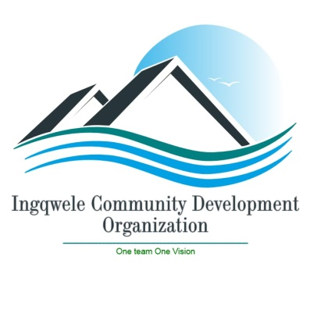

**CONTACT DETAILS**

**073 390 9086 / 083 369 7541**

[ingqweleacademy@gmail.com](mailto:ingqweleacademy@gmail.com)

**209 Cyril Zulu Grove Road**

**Umlazi**

**Durban**

**4031**

**REG No : 170 – 996**

**B-BBEE : Level 1**

**Tax N : 943362198**

**INGQWELE COMMUNITY DEVELOPMENT ORGANISATION PROFILE**

**BACKGROUND**

2016 at Umlazi F section. It provides with extra classes for Mathematics, Physical Sciences, Accounting and Life Sciences. It promotes social responsibility programs for youth through dialogues and donates **Ingqwele Community Development Organization** was established and began operating since January sanitary towels and school uniforms to children who are orphans. Ingqwele also provide awareness programs on gender based violence.

**OUR VISION**

* To be recognized as South Africa’s leading youth academy and to form programmes that will encourage the youth to learn and to see the vitality of education.
* To see orphans living in the comfortable and conducive environment that enables them to pursue their career path.
* The organization is called to develop the youth by implementing effective youth development programmes.

# Mission

To produce students who pass with high levels so that they do not encounter any hindrances when they apply for bursaries and also inspire them to be responsible, resilient and to equip youth with the necessary skills to confront the forth industrial revolution.

# Mission

To produce students who pass with high levels so that they do not encounter any hindrances when they apply for bursaries and also inspire them to be responsible, resilient and to equip youth with the necessary skills to confront the forth industrial revolution.

# Our Values

***We value:***

* The spirit of Ubuntu
* Integrity
* Mutual respect
* Professionalism
* Innovativeness
* Teamwork

# Love Education Day

Usually, on the 12th of February every year, **Ingqwele** celebrate its occasion that is called ‘Love Education Day’ where students who come from indigence are given calculators, school uniforms and stationeries. On such occasions, students are not only advised to pursue careers that only require Mathematics and Physical Sciences, but also those that are well in-synch with their personalities. It is unwise to coerce a person into selecting a career that s/he does not even like. That is like asking a person who has no fingers to play a guitar. In so doing, we are of view that we are contributing into making a better South Africa with educated bureaucrats. Students who passed their matric are given registration fees as a symbol of showing appreciation and thanking them for the way they performed during their final examinations. This helps in reducing the number of matriculates who passed from staying at home due to being unable to pay registration fees.

**Positive outcomes**

* We enable to assist grade 12 learners to be admitted at higher education institutions
* We encouraged learners to apply for Learnerships with the aim of acquiring skills
* We assisted youth with making of identity document books or cards
* We empowered youth with the literacy of life skills
* We assisted youth with managerial skills to establish their own businesses with the aim to encourage job makers instead of job seekers
* We also assist unemployment graduate to find internship and request them to volunteer in the organisation with the intention of gaining experience

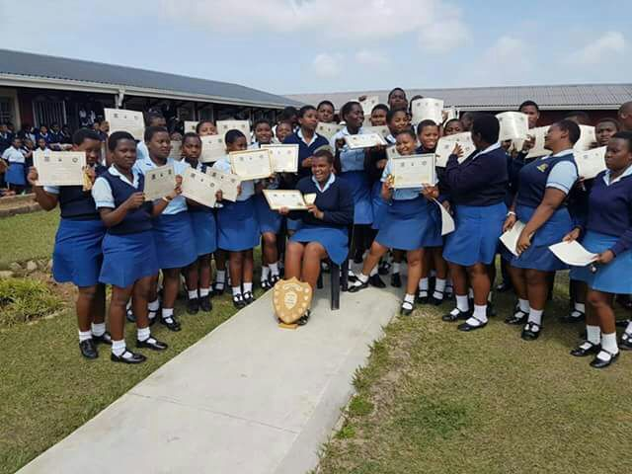

The picture above depicts the award that were given to learners that performed exceptionally well in mathematics and physical science.

**Difficulties of having no working material**

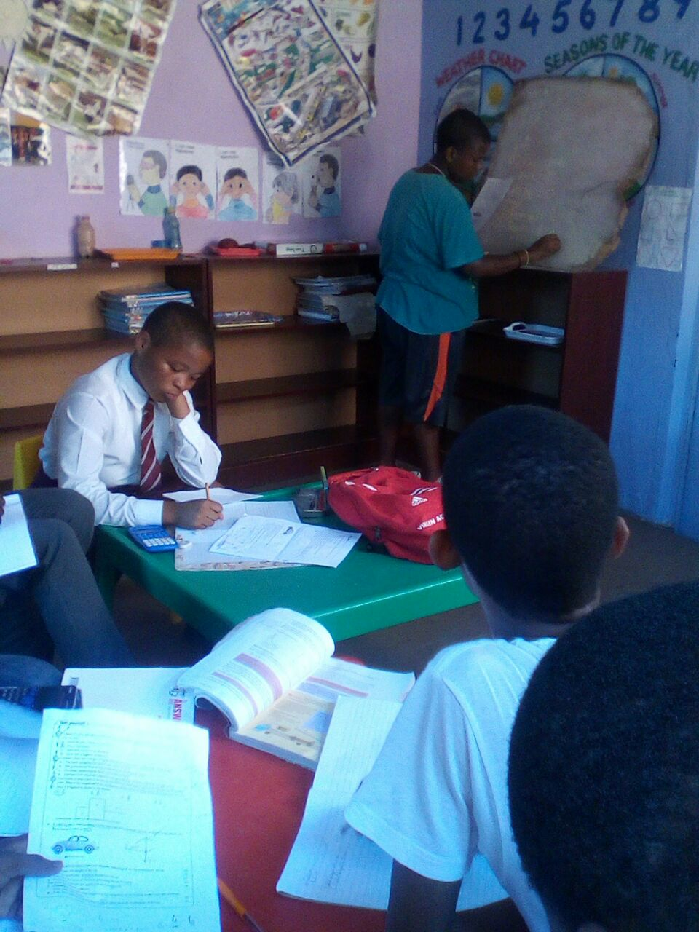

These are the difficulties that students who really need assistance face during the times they are with us. There are no proper chalkboards, only cardboards that aren’t adequate enough for even a single equation to fit. Though circumstances like this makes some students lose interest in coming to get help, there are some who still bear with us and does not let this be a hindrance to their education because they know what they want for their futures. We are optimistic that someday we will have enough equipment that we need in order to make this project successful. In the previous year, we produced one of the best students in the province using this cardboard as our chalkboard. So I believe that if we can get proper chalkboards and other material that we need we can produce more people who pass with excellent results through hard work.

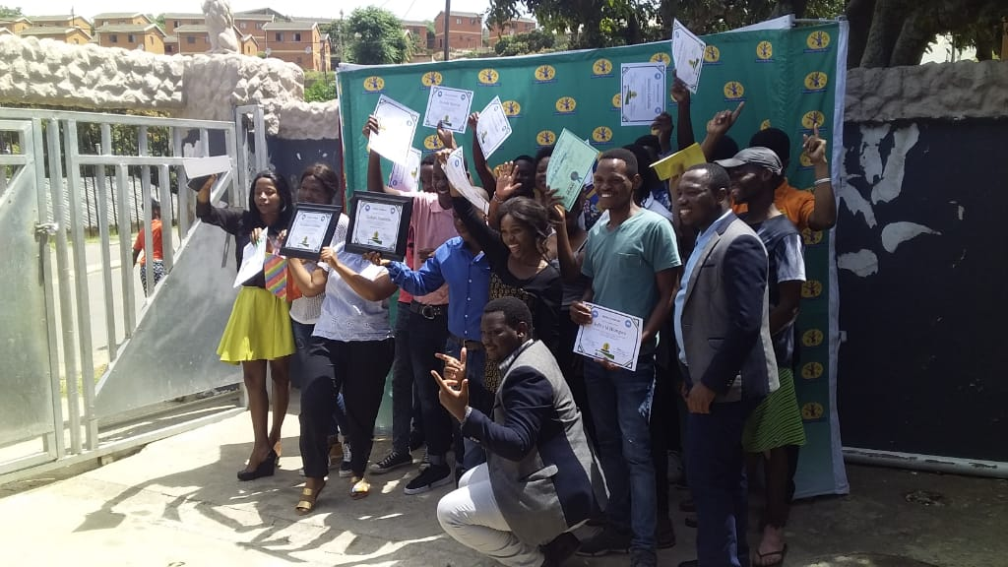

**The picture above illustrate the training by the youth for CV writing and job readiness and the reward of certificates**

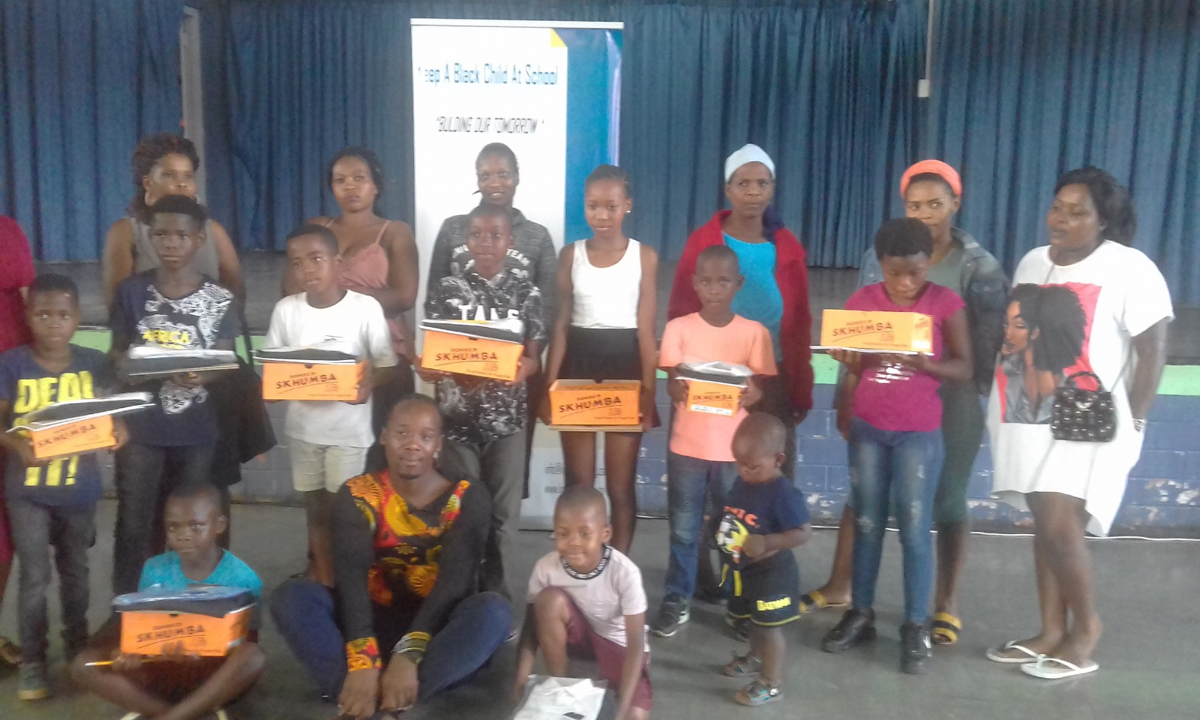

We organised a programme to donate to the children who are orphans with the believe that education can change the living conditions of the poor masses.

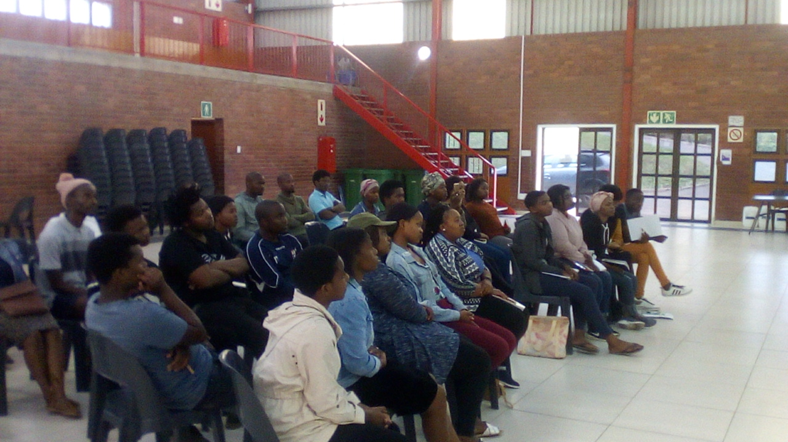

The organisation hosted a workshop for youth 11 March 2020.The workshop was implemented in assisting youth in leadership skills so that they could empower themselves and decrease job seeker and improve job makers in our community.

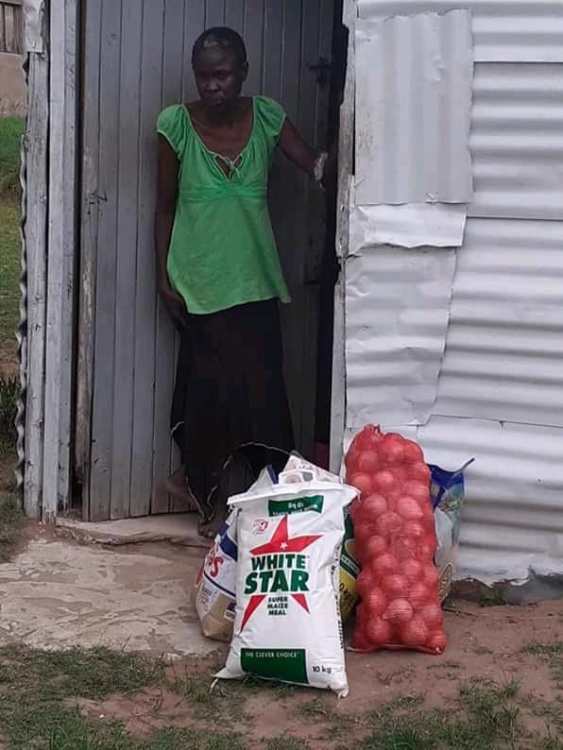

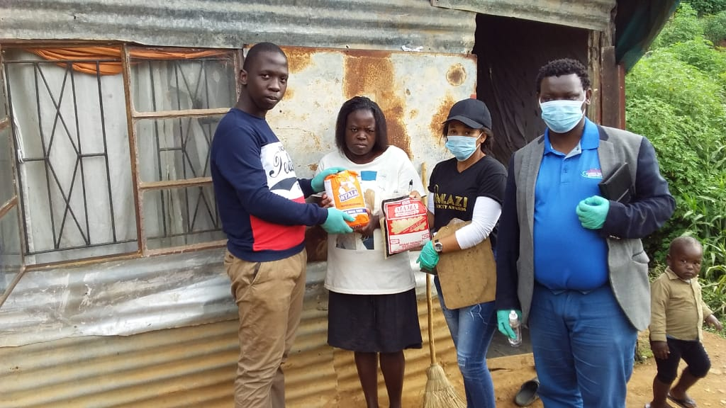

The pictures above depicts the donation that was made by Ingqwele community development to the family from disadvantage background during the pandemic of COVID-19

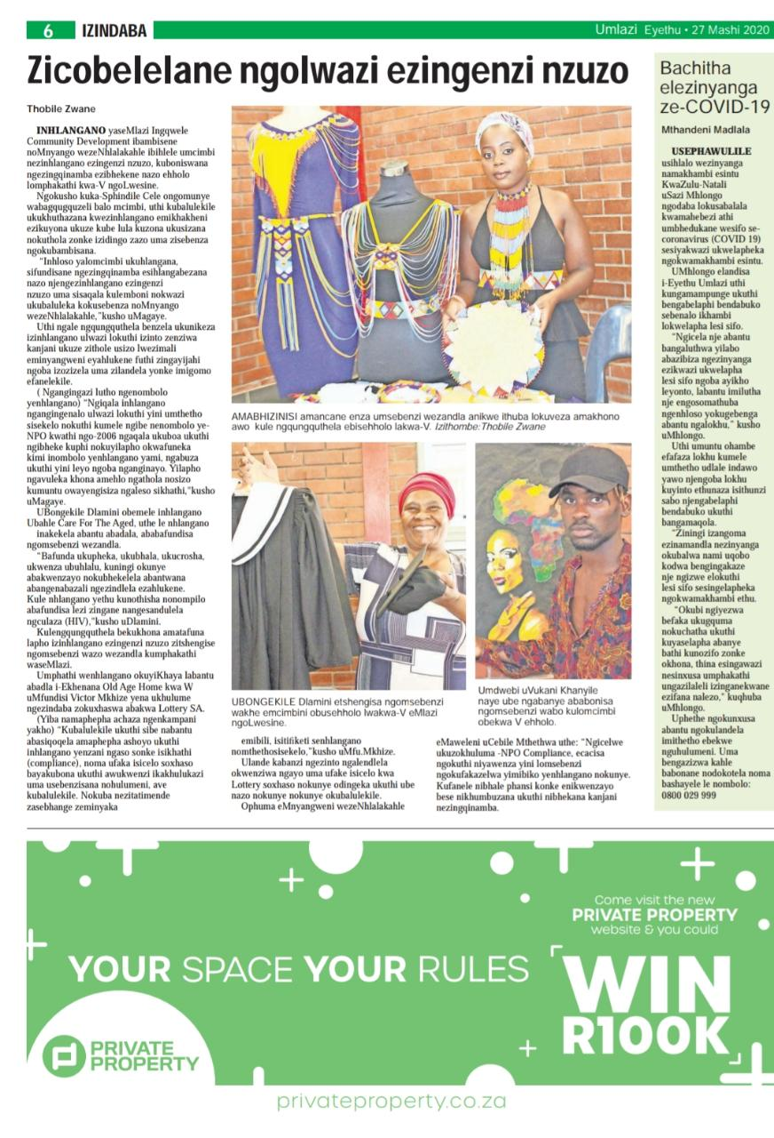

This above article shows the workshop that was called Youth NPO Capacity Building Workshop, organised by Ingqwele community development organisation where by the different sectors of organisations sure casing their work and services that they rendering in different communities

We were invited different stakeholders to link their NPO with their relevant department when they are looking for funding.

**Conclusion**

**Youth on a Mission has a dream of improving the living conditions of young people in Umlazi because the future of our community and that of our country is in the hands of young people of today. Hence, we appeal to your organisation and to your kind heart to join us as we attempt at directing our young people to their brightest future. With the support of organisations like yours, achieving this dream is possible. We strongly believe that a brighter future is for everyone who is committed, but they need to be supported and guided through the right paths.**

**“Safety and security don’t just happen; they are a collective consensus and public investment. We owe our children, the most vulnerable citizens in our society, a life free of violence and fear,”- *Nelson Mandela.***

**“There can be no keener revelation of a society’s soul than the way in which it treats its children,” said Nelson Mandela. That is why this academy focuses on making better the lives of many children. We want to follow in his footsteps of making a better South Africa with education.**

**Our deepest fear is not that we are inadequate. Our deepest fear is that we powerful beyond measure. It is our light, not our darkness that most frightens us. We ask ourselves, who am I to be brilliant, gorgeous, talented, and fabulous? Actually, who are we not to be?’’- *Marianne Williamson***